

**IMPORTANT Member Communication – Member Investment Choice – Lifestage Portfolios**

Dear Member

As a member of the University of Johannesburg Pension Fund, you have the option to select which portfolio your monthly contributions and fund credit are invested in. The Board of Trustees have after a long period of investigation and advice from our service providers and advisors, decided to make some changes to the current structure of the investment choice framework available to you.

Your retirement investment horizon also does not end at age 65, but will continue into retirement as long as you receive your monthly pension. It is important to also match you pre-retirement investment strategy to what you want to do with your benefit after retirement, in order to optimize one’s retirement and investment planning.

The essence of the above, is that members in a retirement fund can and do have very different needs, both before AND after retiring, and therefore the design of any member choice framework, must take cognizance of this fact. In summary, members can make the following decisions at the point of retirement:

1. Invest in a **living annuity** with a high allocation to equities
2. Invest in a **living annuity** with a low allocation to equities
3. Take their retirement benefit in **cash** (in whole or in part, depending on the value)
4. Invest in a **life, with-profit or inflation-linked annuity**

With the aim of assisting members to better align your pre- and post-retirement investment strategies, the Trustees will be making the following enhancements to the current framework

Your current default Life-stage Portfolio is designed as follows:

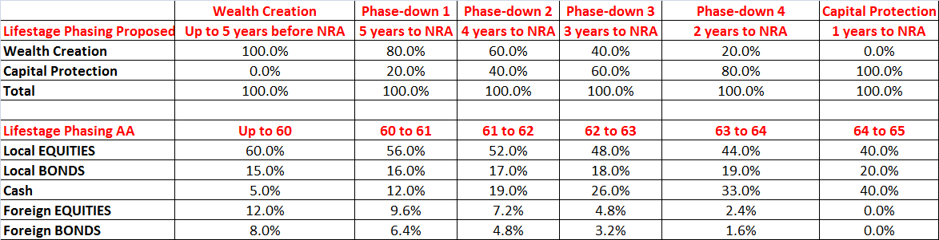

This Life-stage Portfolio will remain the default portfolio, and is best suited for a member who wishes to purchase a low equity living annuity at retirement. The following **additional** portfolio channels will be made available to you as member-choice options:

1. A channel for members who will be purchasing a high-equity living annuity. Members will remain invested in the Wealth Creation Portfolio
2. A channel for members who will be taking cash (at the point of retirement). Members will transition into the Money Market Portfolio
3. A channel for members who wish to guarantee their fund credit in the pre-retirement period, and prevent any investment market losses in the portfolio. Members will transition into the Capital Guarantee Portfolio
4. A channel for members who wish to purchase a life, with-profit or inflation-linked annuity. Members will transition into a new portfolio option called the Alexander Forbes Investments Protector Portfolio

The AF Investments Protector Portfolio is designed for members in the pre-retirement phase who will be purchasing a life, with-profit or inflation-linked annuity at the point of retirement. It has three integrated objectives:

1. Protect the expected income replacement value of a member’s accumulated retirement savings for retirement
2. Protect the capital value of a member’s retirement savings over 24 month periods
3. Maximise real returns (returns less consumer inflation) whilst achieving objectives 1 and 2

A summary of the portfolio channels and phasing methodology is shown in the table below:

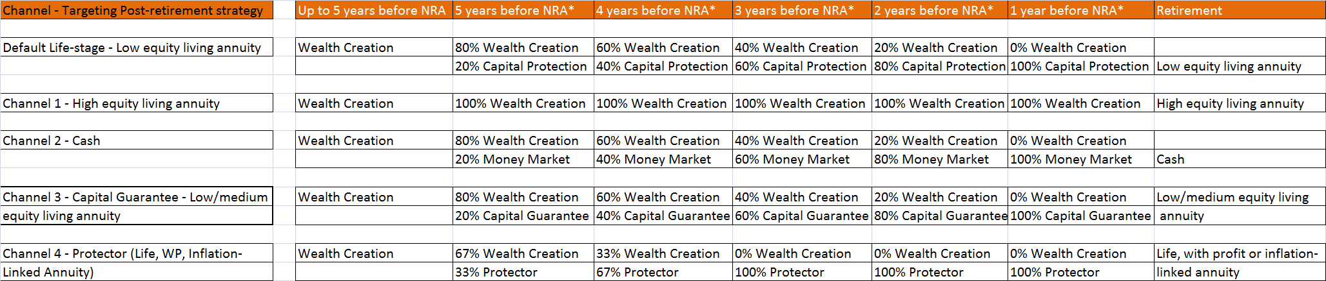

* It is important to note that in each year where phasing down from one portfolio to another takes place, this will take place quarterly, i.e. there will be 4 phasing events that take place in each year (currently this takes place once per year).

It is imperative that members receive the appropriate financial advice and assistance in order to make the appropriate investment decisions that are best suited to you. The Trustees have therefore put the following measures in place in order to ensure that this advice framework gets implemented.

1. 7 years before you are due to retire, a retirement planning workshop will be held, which will assist you with starting to think about what portfolio strategy is best suited to your specific circumstances. At this workshop, you will be able to make a one-on-one appointment with a certified financial planner, to discuss your specific circumstances in more detail
2. 5 years before you are due to retire, another retirement planning workshop will be held, where you will be given the option to elect the pre-retirement portfolio that is best suited to your specific circumstances. You will also be able to set up an appointment with a certified financial planner, to discuss your specific circumstances in more detail
3. A certified financial planner will continue to visit each of the University’s campuses on a monthly basis, to meet with you on a one-on-one basis. You are required to make an appointment in this regard

The Trustees would like to stress that you avail yourself of this service that will be made available to you. It is extremely important that you set up an appointment with the financial planner, BEFORE making any pre-retirement investment decisions. The impact of making the incorrect decision could affect how much money you have to live off in your retirement years.

The effective date of the above changes will be 1 February 2018.

As always, the Board reminds you that it is your responsibility to discuss your options with your financial advisor.

In the event that you have any specific queries, please do not hesitate to contact me.

Regards

Evette Vanrenen-Linford

Principal Officer

Office: 011 559 4898

E-mail: Evettevl@uj.ac.za